ENVIRONMENTAL COMPLIANCE STATUS REPORT OF STIPULATED CONDITIONS IN ENVIRONMENTAL CLEARANCE

For

M/S. SHREE VAISHNAV CASTING PVT. LTD.

Manufacturing of MS Ingots and Billets

At

Plot No. B-3, Palkhed MIDC, Taluka Dindori,
District Nashik, Maharashtra

CONTENTS OF REPORT
Sr. No. | Particulars | Page No.
 | Introduction & Project Description | 1
 | History of the Project | 1
 | Current Status of The Project | 1
 | Site Photographs | 1-2
 | Environmental Clearance Details | 3-4
 | Stipulated Conditions of Environmental Clearance and Compliance status | 5-12
 | Annexures :
 | Annexure 1 : 1st Consent to Establish
 | Annexure 2 : Environmental Clearance Copy
 | Annexure 3 : 1st Consent to Operate
 | Annexure 4 : Consent to Establish Copy
 | Annexure 5 : Consent to Operate Copy
 | Annexure 6 : Renewal of CTO
 | Annexure 7 : Certificate of Incorporation
 | Annexure 8 : Monitoring Reports
 | Annexure 9 : Green Belt plantation photographs
 | Annexure 10 : Occupational Health and Safety Reports
 | Annexure 11 : Environment Management Cell
 | Annexure 12 : Newspaper Advertisement Copy
 | Annexure 13 : Environmental Statement Form V

- INTRODUCTION & PROJECT DESCRIPTION:

M/s. Shree Vaishnav Casting Pvt. Ltd. (SVCPL) is an existing manufacturing unit located at Plot No. B-3, Dindori MIDC, Palkhed Road, Taluka Dindori, District Nashik, Maharashtra. The geographical coordinates of the project are 20°12'2.82"N & 73°51'35.81"E.

The company has obtained 1st Consent to Establish (Refer Annexure – 1) for manufacturing of MS ingots and Billets with quantity of 7500 Ton/M dated 20.03.2009 and Environmental Clearance (Refer Annexure – 2) vide letter No. SEAC- 2010/CR-183/TC-2 dated 14th October, 2010 for manufacturing of MS ingots and Billets with a quantity of 7500 Ton/M from Environment Department, Government of Maharashtra. Industry has obtained Consent to Operate from MPCB dated 05.12.2023 (Refer Annexure – 3) for the same.

Thereafter, Industry has obtained Consent to Establish dated 03.05.2014 (Refer Annexure – 4) for manufacturing of TMT Bar 7350 Ton/Month and Consent to 1st Operate for Expansion with amalgamation (Refer Annexure – 5) of existing consent dated 27.05.2015 and CTO Renewal (Refer Annexure – 6) from MPCB for manufacturing of MS Billets (7500 Ton/M) & TMT Bars (7350 Ton/M) and by-product - MS Scrap & Missroll (50 Ton/M) dated 16.11.2023 valid upto 31.12.2024.

- HISTORY OF THE PROJECT :

Shree Vaishnav Casting Pvt. Ltd. is having incorporation certificate dated 1st May, 2007 with Corporate Identity number U27310MH2007PTC170497 & it’s registered at Registrar of Companies, Mumbai. Refer Incorporation certificate at Annexure-7.

- M/s. Shree Vaishnav Casting Pvt. Ltd. (SVCPL) is having Environmental Clearance for manufacturing of ingots and billets vide letter no. SEAC-2010/CR-183/TC-2 dated 14.10.2010.
- As per EIA Notification SO 1533 dated 14 September 2006, its activity is classified in metallurgical industries (ferrous & nonferrous) as 3(a) secondary non-toxic steel manufacturing company and is classified under category B1 which mandates obtaining prior Environmental Clearance from State Expert Appraisal Committee (SEAC).
- The company has obtained 1st Consent to establish for manufacturing of MS ingots and Billets with a quantity of 7500 Ton/M dated 20.03.2009 and Environmental Clearance vide letter No. SEAC-2010/CR-183/TC-2 dated 14th October, 2010 for manufacturing of MS ingots and Billets with a quantity of 7500 Ton/M from Environment Department, Government of Maharashtra. Industry has obtained Consent to Operate from MPCB dated 05.12.2023 for the same.
- Thereafter, M/s. Shree Vaishnav Casting Pvt. Ltd. (SVCPL) engaged in manufacturing of MS Billets and TMT Bars at Plot No. B-3, B-9 and B-10, Dindori MIDC, Palkhed Road, Taluka Dindori, District Nashik, Maharashtra.
- Industry has obtained Consent to Establish dated 03.05.2014 for manufacturing of TMT Bar 7350 Ton/Month and Consent to 1st Operate for Expansion with amalgamation of existing consent dated 27.05.2015 and CTO Renewal from MPCB for manufacturing of MS Billets (7500 Ton/M) & TMT Bars (7350 Ton/M) and by-product- MS Scrap & Missroll (50 Ton/M) dated 16.11.2023 valid upto 31.12.2024.
- As per MoEF&CC Notification vide No. S.O.3250 (E) dated 20th July 2022, it is mandatory to take Environmental Clearance from the State Level Environment Impact Assessment Authority. As per above notification the unit needs to obtain environmental clearance for its existing activities as well as proposed expansion activities. In line with statuary requirement the unit applied for obtaining “ToR” which was issued vide reference number SIA/MH/IND1/457155/2023 dated 01.01.2024 for the preparation of EIA report.
- The capital investment of the project was Rs. 34.05 Crores. Total employment is of 125 people.
- There are no national parks, Biosphere Reserves, Tiger/Elephant Reserves, Wildlife Corridors etc. within 10 Km Study Area. Kadwa river is flowing at a distance of 2.45 Km from East to North.
- The total water requirement for manufacturing of MS Billets and TMT Bars is 250 CMD. The source of water is from MIDC water supply scheme. Zero effluent is generated from industrial activities as the water used for cooling is re-circulated back into the process. Only domestic sewage @40 CMD is generated and the same is treated in STP. STP of capacity 50 CMD is installed on site. The treated sewage is used for gardening and flushing. Unit is having a connected load of 18584 kW sanctioned by MSEDCL, also D.G. Set of 500 kVA is provisioned for emergency use in case of power failure. Diesel is used as fuel for D.G. The fuel is being sourced from local market.
- Fuel in the form of Diesel is required for D.G. Set under existing unit. Induction furnace is being electrically operated. Since no any fuel is burned in induction furnace and no refining procedures are executed, the emissions solely depend on the cleanliness and the composition of the charged material
- Condition Compliance Report issued by RO; MPCB HQ, Mumbai – Visit of RO, MPCB HQ, Mumbai & Report has been issued from MPCB vide letter No MPCB/RO/2399 dated 11.06.2024.
- Six Monthly compliance report is also submitted.

- STATUS OF THE PROJECT:

The company is formed in 2007 year, started production in 2011 to November 2015. From December 2015 to February 2024 industry had stopped their production; now industry is in operation.

- SITE PHOTOGRAPHS :

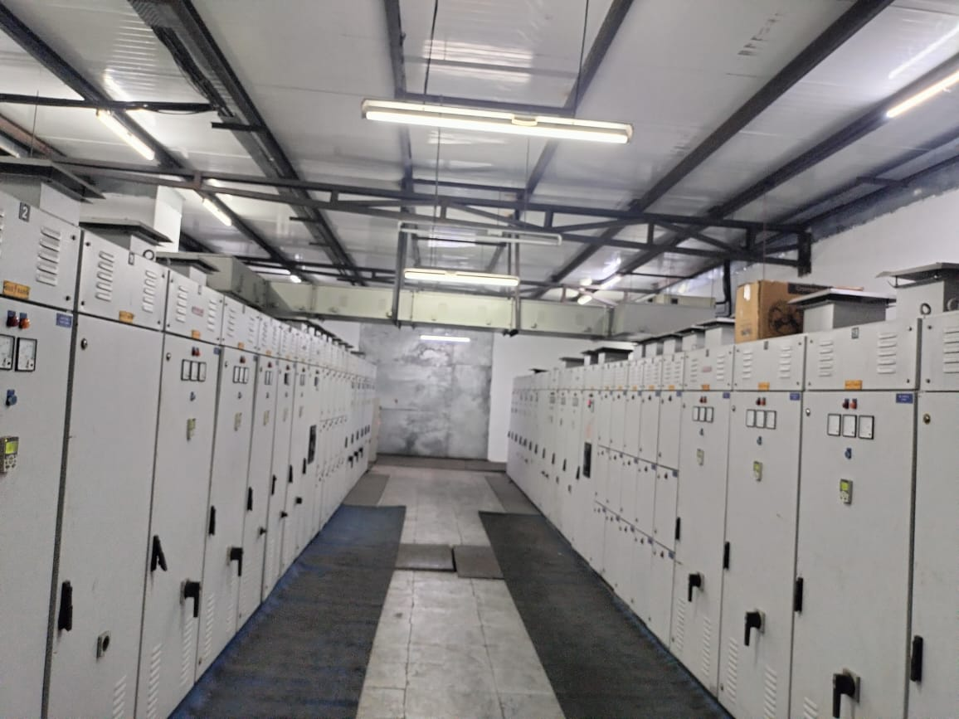 | 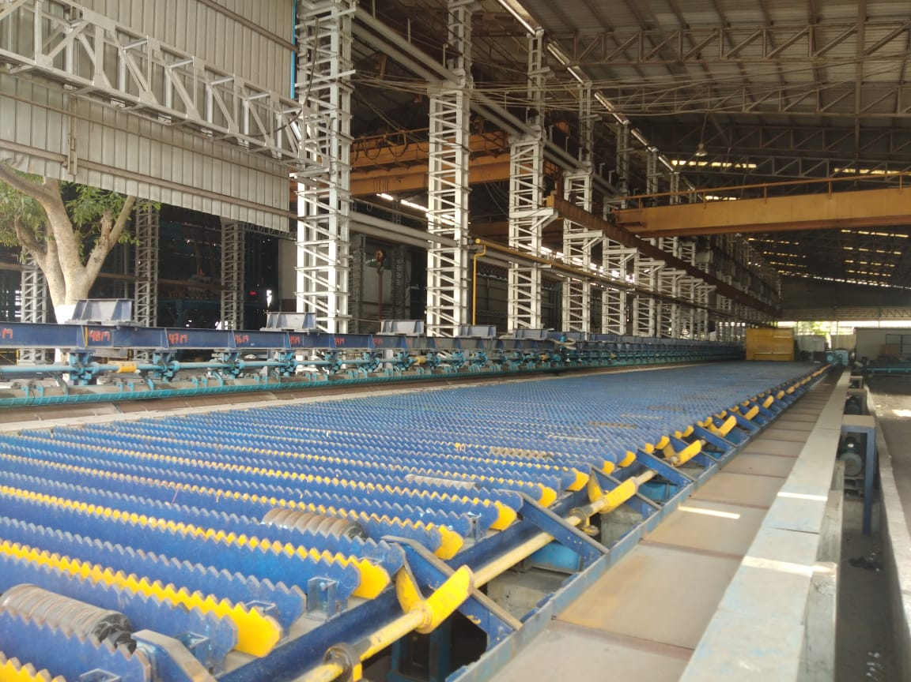
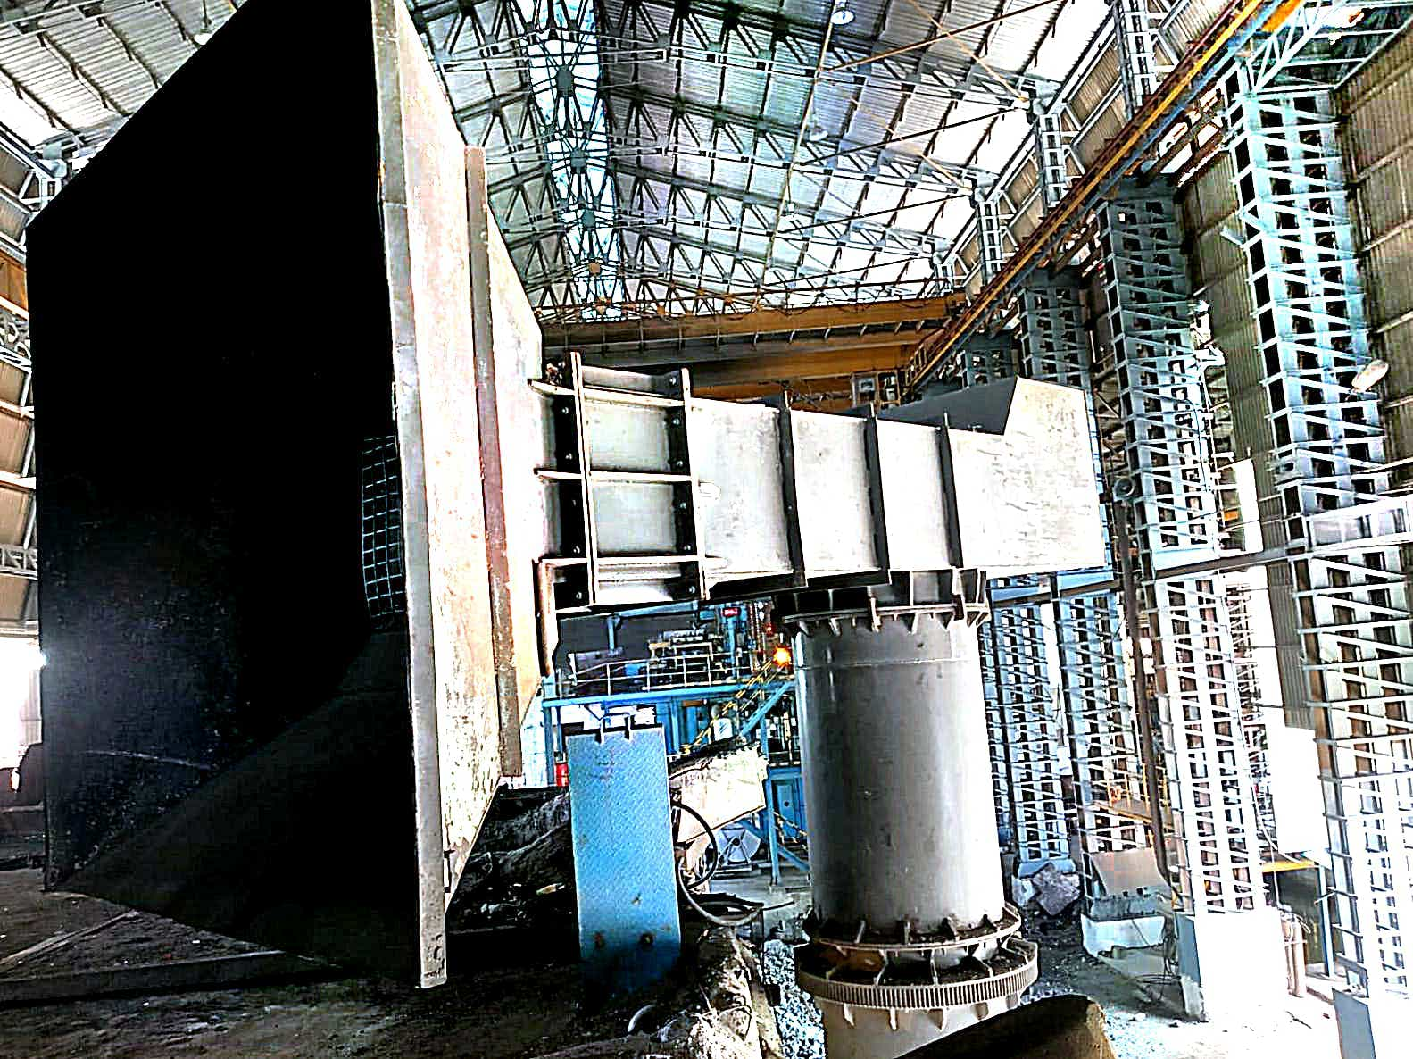 | 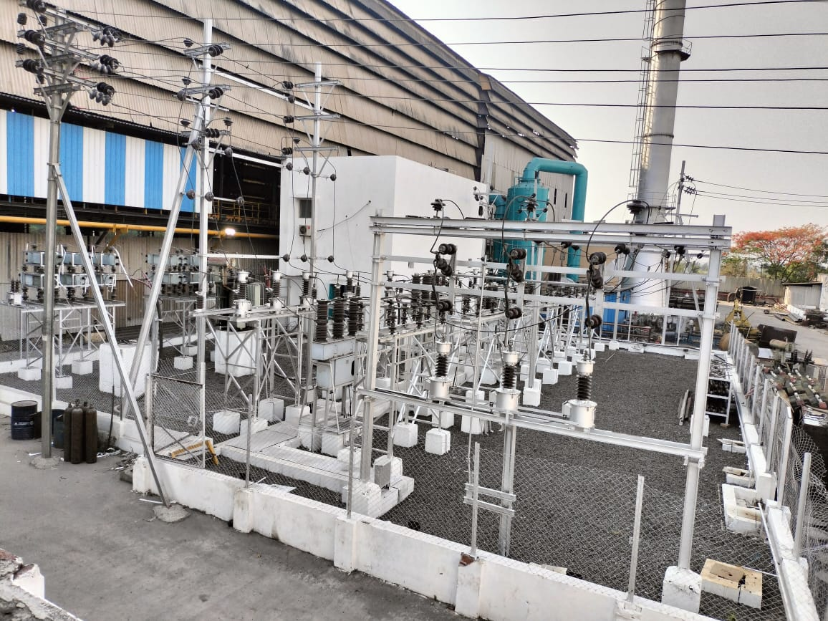
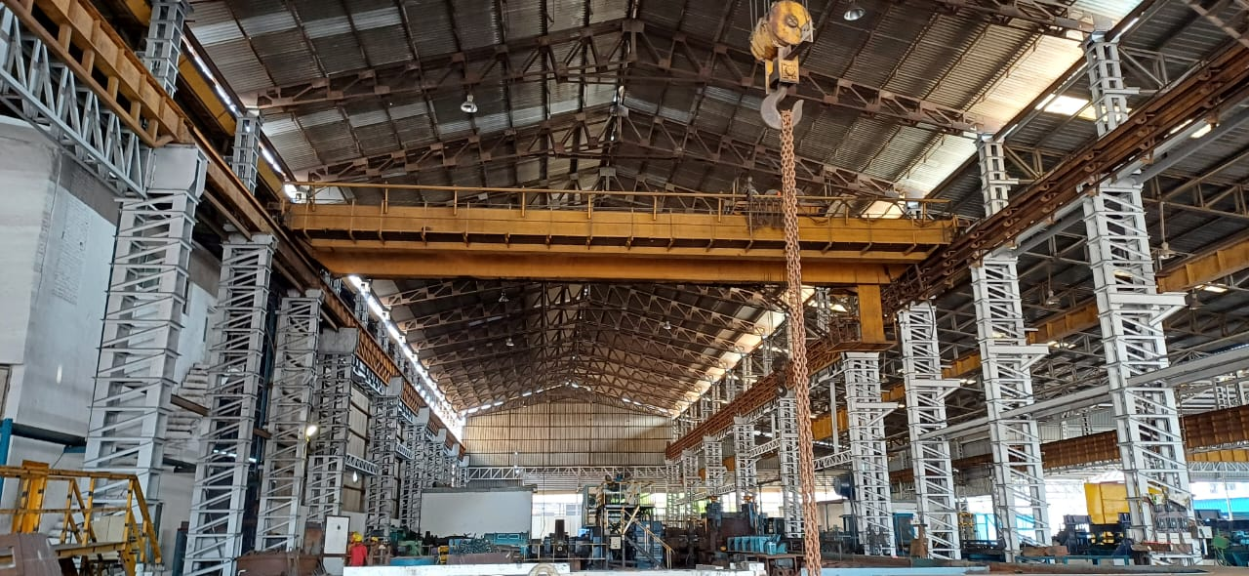  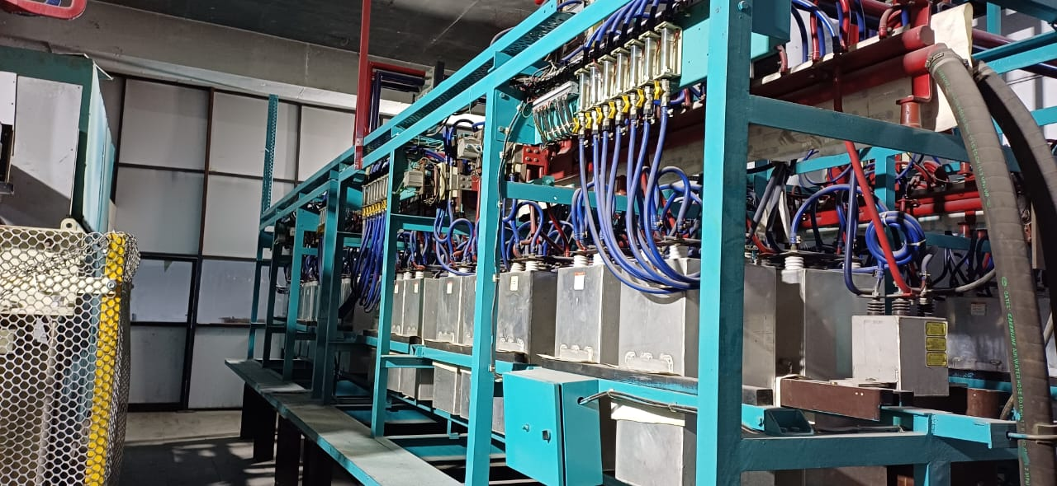 | 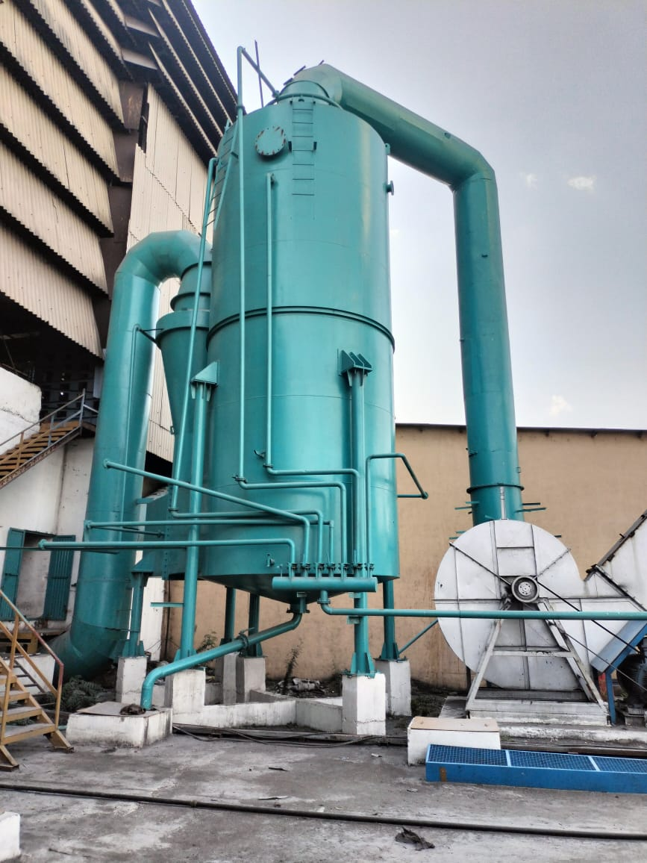  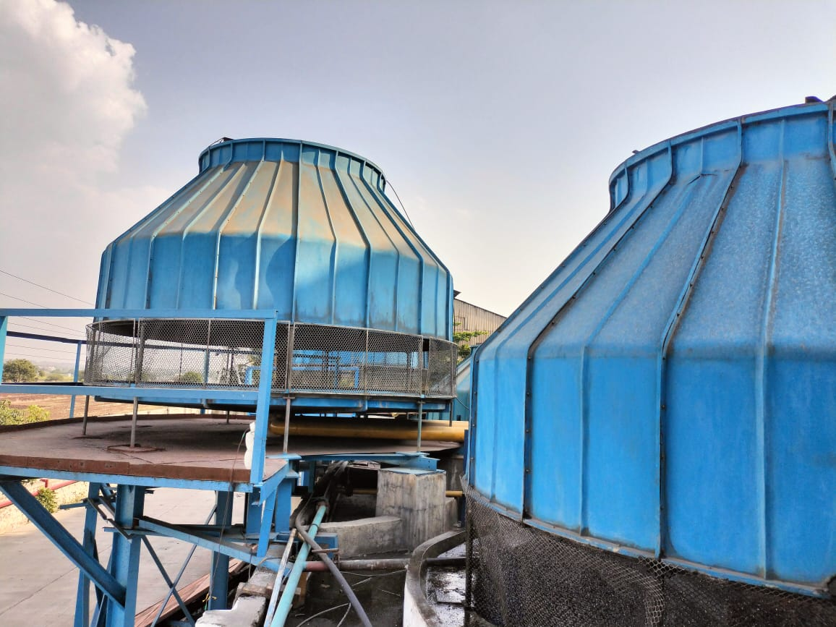

- ENVIRONMENTAL CLEARANCE DETAILS

- M/s. Shree Vaishnav Casting Pvt. Ltd. (SVCPL) is having Environmental Clearance for manufacturing of ingots and billets vide letter no. SEAC-2010/CR-183/TC-2 dated 14.10.2010.
- The proposal was considered as per EIA Notification-2006, by the State Level Expert appraisal Committee, Maharashtra in its 21st meeting and decided to recommend the project for prior environmental clearance to SEIAA.
- Information submitted was considered by state Level Environment Impact Assessment Authority in its 26th meeting held on 26.08.2010. Authority noted the clarification dated 14.09.2010 that the production unit is non-toxic secondary metallurgical processing industry.
- It is noted that the proposal is for grant of Environmental Clearance manufacturing unit of MS ingots and billets at B-3, Palkhed MIDC, Taluka Dindori, District :Nashik by M/s. Shree Vaishnav Casting Pvt. Ltd. The project considered by SEAC under EIA notification 2006, screening category is 3(a).
- Project information from submitted & considered documents is summarised as below:

Name of the project | : | Manufacturing unit of MS ingots and billets
Type of project | : | Industrial project
Project Proponent | : | M/s. Shree Vaishnav Casting Pvt. Ltd.
Location of the project | : | Plot no. B-3, MIDC Palkhed, Taluka Dindori, District Nashik  Latitude : 19º35’ and 20º52’N  Longitude : 73º16’ and 74º56’E
Total plot area | : | 26,609 m²
Estimated cost of the project | : | Rs. 34.05 Crores

- STIPULATED CONDITIONS OF ENVIRONMENTAL CLEARANCE AND COMPLIANCE STATUS

Sr. No. | EC CONDITIONS | COMPLIANCE STATUS
A. GENERAL CONDITIONS
 | The project proponent clarified that the production unit is non-toxic secondary metallurgical processing industry. MPCB should ensure this while granting consent to establishment & operate. MPCB also ensure that raw material which will be used in this unit, particularly metal scrap, should be non-hazardous & nontoxic. Project proponent should submit the copy of Consent to establishment & operate obtained accordingly to this department. | Noted and Complied.  The production unit of M/s. Shree Vaishnav Casting Pvt. Ltd. is a non –toxic secondary metallurgical unit. Also, the raw material used here i.e. metal scrap is non-hazardous. Refer Annexures 3-6 for all the consent copies i.e. establish to operate.
 | No land development / construction work preliminary or otherwise relating to the project shall be taken up without obtaining due clearance from respective authorities. | Noted and Complied.  No land development / construction work will be done without obtaining prior clearance from respective authorities.  The company has obtained 1st Consent to Establish for manufacturing of MS ingots and Billets with quantity of 7500 Ton/M dated 20.03.2009 and Environmental Clearance vide letter No. SEAC- 2010/CR-183/TC-2 dated 14th October, 2010 for manufacturing of MS ingots and Billets with a quantity of 7500 Ton/M from Environment Department, Government of Maharashtra. Industry had started its production from 2009 to November 2015. byproduct- MS Scrap & Missroll (50 Industry has obtained Consent to Establish dated 03.05.2014 for manufacturing of TMT Bar 7350 Ton/Month and Consent to 1st Operate for Expansion with amalgamation of existing consent dated 27.05.2015 Thereafter, and CTO Renewal from MPCB for manufacturing of MS Billets (7500 Ton/M) & TMT Bars (7350 Ton/M) and Ton/M) dated 16.11.2023 valid upto 31.12.2024. Thereafter, from 2015 till March 2024 industry was not in operation. As per NCLT Order Industry has started its operational activities in the name of Shree Vaishnav Casting Pvt. Ltd from March 2024. Hence, we are submitting herewith compliance to existing EC conditions.
 | No additional land shall be used /acquired for any activity of the project without obtaining proper permission. | Noted. Project proponent has consented to the condition.
 | For controlling fugitive natural dust, regular sprinkling of water & wind shields at appropriate distances in vulnerable areas of the plant shall be ensured. | Complied.  Internal roads are paved roads. Hence there shall be negligible fugitive dust emissions. In addition to this, regular water sprinkling is carried out for control of fugitive dust. The same practise shall be continued.
 | Regular monitoring of the air quality, including SPM & SO₂ levels both in work zone and ambient air shall be carried out in and around the power plant and records shall be maintained. The location of monitoring stations and frequency of monitoring shall be decided in consultation with Maharashtra Pollution Control Board (MPCB) & submit report accordingly to MPCB. | Complied.  Regular monitoring is done by MPCB and MoEFCC approved laboratory and the reports are attached at Annexure-8
 | Necessary arrangement shall be made to adequate safety and ventilation arrangement in furnace area. | Complied.  Project proponent has taken necessary steps w.r.t. safety and ventilation in furnace area.
 | Proper Housekeeping programmes shall be implemented. | Complied.  Proper housekeeping programmes are implemented on site.
 | In the event of the failure of any pollution control system adopted by the unit, the unit shall be immediately put out of operation and shall not be restarted until the desired efficiency has been achieve. | Noted.  Operations shall be immediately closed in case of any operation failure. In case of such emergency, protocols are strictly followed which include immediate power connection cut off and isolation.
 | A stack of adequate height based on DG set capacity shall be provided for control and dispersion of pollutant from DG set (if applicable). | Complied.  Adequate stack height of 3 m is provided to D.G. set. The same will be increased upto 5 m.
 | A detailed scheme for rainwater harvesting shall be prepared and implemented to recharge ground water. | Complied.  Rainwater harvesting scheme is prepared and implemented on site.
 | Arrangement shall be made that effluent and storm water do not get mixed. | Complied.  There is no mixing of storm water and effluent. Effluent in the form of sewage is generated and the same is treated in STP. Industrial effluent in the form of industrial cooling is recirculated back into process. Hence, no effluent discharge.
 | Periodic monitoring of ground water shall be undertaken and results analyzed to ascertain any change in the quality of water. Results shall be regularly submitted to the Maharashtra Pollution Control Board. | Complied.  Ground water monitoring is done regularly. Refer Annexure-8 for ground water monitoring report.
 | Leq of Noise level shall be maintained as per standards. For people working in the high noise area, requisite personal protective equipment like earplugs etc. shall be provided. | Complied.  Due care is been taken by industry regarding exposure to high noise area of workers. Personal Protective Equipments are provided to workers. Personal Protective Equipments like Ear plugs, earmuffs are provided to the workers working in noise prone area. The same practise shall be continued. Noise level is maintained well within standards. Refer Annexure-8 for noise monitoring reports.
 | The overall noise levels in and around the plant are shall be kept well within the standards by providing noise control measures including acoustic hoods, silencers, enclosures, etc. On all sources of noise generation. The ambient noise levels shall confirm to the standards prescribed under Environment (Protection) Act, 1986 Rules, 1989. | Complied.  Due care is been taken by industry regarding exposure to high noise area of workers. Personal Protective Equipments are provided to workers. Also, enclosures are provided on site. Noise level is maintained well within standards. Refer Annexure-8 for noise monitoring reports.
 | Green belt shall be developed & maintained around the plant periphery, Green Belt Development shall be carried out considering CPCB guidelines including selection of plant species and in consultation with the local DFO/ Agriculture Dept. | Complied.  Green belt shall be developed on an area about 5600 Sq.m. Photographs of green belt plantation is enclosed at Annexure-9. Earlier manufacturing activity of SVCPL was started in the year 2011 till November 2015. After November 2015 till March 2024 industry was not in operation. Hence, the plantation shall be again done now and the list of trees is enclosed.
 | Adequate safety measures shall be provided to limit the risk zone within the plant boundary, in case of an accident. Leak detection devices shall also be installed at strategic places for early detection and warning. | Complied.  Safety measures are taken on site like fire alarms, fire extinguishers provision, etc. Leak detection devices are installed on site. Display boards are present for emergency treatment and handling procedure in case of any accident.
 | Occupational health surveillance of the workers shall be done on a regular basis and record maintained as per Factories Act. | Complied.  Occupational health check-up reports are carried out regularly. Refer Annexure-10 for the same.
 | The company shall make the arrangement for protection of possible fire hazards during manufacturing process in material handling. | Complied.  Safety measures are taken on site like fire alarms, fire extinguishers provision, etc. Regular Training on Use of PPEs & using fire extinguishers during fire hazard. Moreover, training is being provided to all the workers for protection of possible fire hazards during manufacturing process and material handling.
 | The project authorities must strictly comply with the rules and regulations with regard to handling and disposal of hazardous wastes in accordance with the Hazardous Waste (Management and Handling) Rules, 2003 (amended). Authorization from the MPCB shall be obtained for collections/ treatment/ storage/ disposal of hazardous wastes. | Complied.  Complied.  The industry is following all the rules and regulations i.e. Hazardous Waste (Management and Handling) Rules, 2003 and its subsequent amendments till date. Annual returns for hazardous waste submitted for this current year.
 | The company shall undertake following Waste Minimization Measures:  - Metering of quantities of active ingredients to minimize waste. | Noted. Complied/ Implemented
 | - Reuse of by- products from the process as raw materials or as raw material substitutes in other process. | Complied  Active ingredients are dosed to minimize waste.
 | - Maximising Recoveries | By-products from the process are recycled as raw materials or as a substitute for raw materials in other processes.
 | - Use of automated material transfer system to minimize spillage | Recovery is enhanced
 | - Use of “Closed Feed” system into batch reactors | An automatic material transfer system is used to minimize spillage.
 | Regular mock drills for the on-site emergency management plan shall be carried out. Implementation of changes/improvements required, if any, in the on-site management plan shall be the on-site management | Complied.  Monthly Training on Fire Hydrant System & Fire Extinguishers shall be conducted on site. Regular mock drills are conducted for awareness of responsibility. On site emergency plan is prepared and implemented as required.
 | A separate environment management cell with qualified staff shall be set up for implementation of the stipulated environmental safeguards. | Complied.  Team of separate environment management cell with qualified staff is appointed for implementation of the stipulated environmental safeguards.  Refer Annexure-11 for Environment Management Cell.
 | Transportation of ash will be through closed containers and all measures should be taken to prevent spilling of the ash. | Not applicable.  No ash is generated in the existing unit of SVCPL.
 | Separate silos will be provided for collecting and storing bottom ash and fly ash. | Not applicable.
 | Separate funds shall be allocated for implementation of environmental protection measures/EMP along with item-wise breaks-up. These cost shall be included as part of the project cost. The funds earmarked for the environment protection measures shall not be diverted for MPCB & this department other purposes and year-wise expenditure should reported to the MPCB & this department. | Complied.  Capital cost of Rs. 78 Lakhs and O&M cost of Rs.60 Lakhs were initially incurred as an EMP cost.  No. Particulars Capital Cost Recurring cost  1. Air Pollution Control Rs. 3,50,000 50,00000  2. Environment Monitoring and Management 1,00,000 --  3. Occupational Health 50,000 --  4. Green Belt 50,000 2,00,000  5. Solid waste management 50,000 25,00,000
 | The project management shall advertise at least in two local newspapers widely circulated in the region around the project, one of which shall be in the Marathi language local concerned within seven days of issue of this letter, informing that the project has been accorded environmental clearance and copies of clearance letter are available with the Maharashtra Pollution Control Board and may also be seen at Website at https://envis.maharashtra.gov.in | Complied.  Refer Annexure-12 for copy of newspaper advertisement.
 | Project management should submit half yearly compliance reports in respect of the stipulated prior environment clearance terms and conditions in hard & soft copies to the MPCB & this department, on 1st June & 1st December of each calendar year. | Complied.  Project proponent is submitting half-yearly compliance reports in hard and soft copy to MPCB and Department on 1st June and 1st December of every calendar year in respect of terms and conditions of prior environmental clearance.
 | A copy of the clearance letter shall be sent by proponent to the concerned Municipal Corporation and the local NGO, if any, from whom suggestions/representations, if any, ware received while processing the proposal. The clearance letter shall also be put on the website of the Company by the proponent. | Noted and Complied.  A copy of the clearance letter has been given to the concerned Municipal Corporation and the local NGO, and the approval has also been placed on the company's website by the proponent.  www.mitc.com
 | The proponent shall upload the status of compliance of the stipulated EC conditions, including results of monitored data on their website and shall update the same periodically. It shall simultaneously be sent to the Regional Office of MoEF, the respective Zonal Office of CPCB and the SPCB. The criteria pollutant levels namely: SPM, RSPM, SO₂, NOx (ambient levels as well as stack emissions) or critical sectorial parameters, indicated for the project shall be monitored and displayed at a convenient location near the main gate of the company in the public domain. | Noted and complied too. The Status of compliance of the stipulated EC conditions, including results of monitoring data is uploaded on http://parivesh.nic.in The monitoring report is enclosed separately with this application.
 | The project proponent shall also submit six monthly reports on the status of compliance stipulated EC conditions including results of monitored data (both in hard copies as well as by e-mail) to the respective Regional Office of MoEF, the respective Zonal Office of CPCB and the SPCB. | Noted and Complied. The monitoring report is enclosed separately with this application.  The company has obtained 1st Consent to Establish for manufacturing of MS ingots and  Billets with quantity of 7500 Ton/M dated 20.03.2009 and Environmental Clearance vide letter No. SEAC- 2010/CR-183/TC-2 dated 14th October, 2010 for manufacturing of MS ingots and Billets with a quantity of 7500 Ton/M from Environment Department, Government of Maharashtra. Industry had started its production from 2009 to November 2015. Industry has obtained Consent to Establish dated 03.05.2014 for manufacturing of TMT Bar 7350 Ton/Month and Consent to 1st Operate for Expansion with amalgamation of existing consent dated 27.05.2015 Thereafter, and CTO Renewal from MPCB for manufacturing of MS Billets (7500 Ton/M) & TMT Bars (7350 Ton/M) and by product- MS Scrap & Missroll (50 Ton/M) dated 16.11.2023 valid upto 31.12.2024. Thereafter, from 2015 till March 2024 industry was not in operation. As per NCLT Order Industry has started its operational activities in the name of Shree Vaishnav Casting Pvt. Ltd from March 2024. Hence we are submitting herewith compliance to existing EC conditions.
 | The environmental statement for each financial year ending 31st March in Form-V as is mandated to be submitted by the project proponent to the concerned State Pollution Control Board as prescribed under the Environment (Protection) Rules, 1986, as amended subsequently, shall also be put on the website of the company along with the status of compliance of EC conditions and shall also be sent to the respective Regional Offices of MoEF by e-mail. | Industry has submitted Environmental statement Form V. Enclosed copy of same at Annexure-13.
 | The environmental clearance is being issued without prejudice to the court case pending in the court of law and it does not mean that project proponent has not violated any environmental laws in the past and whatever decision of the Hon'ble court will be binding on the project proponent. Hence this clearance does not give immunity to the project proponents in the case filed against him. | Project proponent has consented to the condition.  The company has obtained 1st Consent to Establish for manufacturing of MS ingots and  Billets with quantity of 7500 Ton/M dated 20.03.2009 and Environmental Clearance vide letter No. SEAC- 2010/CR-183/TC-2 dated 14th October, 2010 for manufacturing of MS ingots and Billets with a quantity of 7500 Ton/M from Environment Department, Government of Maharashtra. Industry had started its production from 2009 to November 2015. Industry has obtained Consent to Establish dated 03.05.2014 for manufacturing of TMT Bar 7350 Ton/Month and Consent to 1st Operate for Expansion with amalgamation of existing consent dated 27.05.2015 Thereafter, and CTO Renewal from MPCB for manufacturing of MS Billets (7500 Ton/M) & TMT Bars (7350 Ton/M) and by product- MS Scrap & Missroll (50 Ton/M) dated 16.11.2023 valid upto 31.12.2024. Thereafter, from 2015 till March 2024 industry was not in operation. As per NCLT Order Industry has started its operational activities in the name of Shree Vaishnav Casting Pvt. Ltd from March 2024. Hence we are submitting herewith compliance to existing EC conditions.
 | The Environment department reserves the right to revoke the clearance if conditions stipulated are not implemented to the satisfaction of the department or for that matter, for any other administrative reason | Project proponent has consented to the condition.
 | Validity of Environment Clearance: The environmental clearance accorded shall be valid for a period of 5 years to start of production operations by the power plant. | Project proponent has consented to the condition.
 | In case of any deviation or alteration in the project proposed from those submitted to this department for clearance, a fresh reference should be made to the department to assess the adequacy of the condition(s) imposed and to incorporate additional environmental protection measures required, if any | Project proponent has consented to the condition. No any deviation or alteration is done in the existing project.
 | The above stipulations would be enforced among others under the Water (Prevention and Control of Pollution) Act, 1974, the Air (Prevention and Control of Pollution) Act, 1981. the Environment (Protection) Act, 1986 and rules there under, Hazardous Wastes Management and Handling) Rules, 1989 and its amendments, the public Liability Insurance Act, and in amendments | Noted and agreed.
 | Any appeal against this environmental clearance shall be with the National Environmental Appellate Authority, if preferred, within 30 days as prescribed under Section 11 of the National Environmental Appellate Act, 1997 | Not applicable.

